GDS 2018 AM Lab Topicality Wave 1
Jared Adam

Resolution:

Resolved: The United States federal government should substantially reduce its restrictions on legal immigration to the United States.

T-Permanent Residence

T – Restrictions

T – Restrictions

T-Restrictions—1NC

Restrictions are legal limiting conditions
Oxford No Date, “restriction | Definition of restriction in English by Oxford Dictionaries”, https://en.oxforddictionaries.com/definition/restriction,
limiting condition or measure, especially a legal one. ‘planning restrictions on commercial development’ More example sentences Synonyms 1.1mass noun The limitation or control of someone or something, or the state of being restricted. ‘the restriction of local government power’

Violation-- the aff didn’t specify a legal restriction—just decreases regulations

Vote neg—

Limits- there are infinite regulations on immigration—the aff opens the topic up to things like health status, travel time, personal income etc.— voter for fairness—we only have links predicated off of the assumption that the aff reduces a legal restriction—forces the neg to draw back to generics—leads to stale debates

2NC Regulation ≠ Restriction

Restriction is a prohibition – doesn’t include the terms and conditions of immigration
COURT OF APPEALS 12 [STATE OF WASHINGTON DEPARTMENT OF HEALTH, THE COURT OF APPEALS OF THE STATE OF WASHINGTON, DIVISION I, RANDALL KINCHELOE Appellant. vs. Respondent, BRIEF OF APPELLANT, http://www.courts.wa.gov/content/Briefs/a01/686429%20Appellant%20Randall%20Kincheloe's.pdf]
3. The ordinary definition of the term "restrictions" also does not include the reporting and monitoring or supervising terms and conditions that are included in the 2001 Stipulation. Black's Law Dictionary, 'fifth edition,(1979) defines "restriction" as; A limitation often imposed in a deed or lease respecting the use to which the property may be put.
The term "restrict' is also cross referenced with the term "restrain." Restrain is defined as;
To limit, confine, abridge, narrow down, restrict, obstruct, impede, hinder, stay, destroy. To prohibit from action; to put compulsion on; to restrict; to hold or press back. To keep in check; to hold back from acting, proceeding, or advancing, either by physical or moral force, or by interposing obstacle, to repress or suppress, to curb.

The best lexicography proves restriction and regulation are distinct by definition
Schackleford 17 J. is a justice of the Supreme Court of Florida. “Atlantic Coast Line Railroad Company, a corporation, et al., Plaintiff in Error, v. The State of Florida, Defendant in Error,” 73 Fla. 609; 74 So. 595; 1917 Fla., Lexis
There would seem to be no occasion to discuss whether or not the Railroad Commissioners had the power and authority to make the order, requiring the three specified railroads running into the City of Tampa to erect a union passenger station in such city, which is set out in the declaration in the instant case and which we have copied above. [***29] It is sufficient to say that under the reasoning and the authorities cited in State v. Atlantic Coast Line R. Co., 67 Fla. 441, 458, 63 South. Rep. 729, 65 South. Rep. 654, and State v. Jacksonville Terminal [*631] Co., supra, it would seem that HN14the Commissioners had power and authority. The point which we are required to determine is whether or not the Commissioners were given the authority to impose the fine or penalty upon the three railroads for the recovery of which this action is brought. In order to decide this question we must examine Section 2908 of the General Statutes of 1906, which we have copied above, in the light of the authorities which we have cited and from some of which we have quoted. It will be observed that the declaration alleges that the penalty imposed upon the three railroads was for the violation of what is designated as "Order No. 282," which is set out and which required such railroads to erect and complete a union depot at Tampa within a certain specified time. If the Commissioners had the authority to make such order, it necessarily follows that they could enforce a compliance with the same by appropriate proceedings in the courts, but [***30] it does not necessarily follow that they had the power and authority to penalize the roads for a failure to comply therewith. That is a different matter. HN15Section 2908 of the General Statutes of 1906, which originally formed Section 12 of Chapter 4700 of the Laws of Florida, (Acts of 1899, p. 86), expressly authorizes the imposition of a penalty by the Commissioners upon "any railroad, railroad company or other common carrier doing business in this State," for "a violation or disregard of any rate, schedule, rule or regulation, provided or prescribed by said commission," or for failure "to make any report required to be made under the provisions of this Chapter," or for the violation of "any provision of this Chapter." It will be observed that the word "Order" is not mentioned in such section. Are the other words used therein sufficiently comprehensive to embrace an order made by the Commissioners, such as the one now under consideration? [*632] It could not successfully be contended, nor is such contention attempted, that this order is covered by or embraced within the words "rate," "schedule" or "any report,' therefore we may dismiss these terms from our consideration and [***31] direct our attention to the words "rule or regulation." As is frankly stated in the brief filed by the defendant in error: "It is admitted that an order for the erection of a depot is not a 'rate' or 'schedule' and if it is not a 'rule' or 'regulation' then there is no power in the Commissioners to enforce it by the imposition of a penalty." It is earnestly insisted that the words "rule or regulation" are sufficiently comprehensive to embrace such an order and to authorize the penalty imposed, and in support of this contention the following authorities are cited: Black's Law Dictionary, defining regulation and order; Rapalje & Lawrence's Law Dictionary, defining rule; Abbott's Law Dictionary, defining rule; Bouvier's Law Dictionary, defining order and rule [**602] of court; Webster's New International Dictionary, defining regulation; Curry v. Marvin, 2 Fla. 411, text 515; In re Leasing of State Lands, 18 Colo. 359, 32 Pac. Rep. 986; Betts v. Commissioners of the Land Office, 27 Okl. 64, 110 Pac. Rep. 766; Carter V. Louisiana Purchase Exposition Co., 124 Mo. App. 530, 102 S.W. Rep. 6, text 9; 34 Cyc. 1031. We have examined all of these authorities, as well as those cited by the [***32] plaintiffs in error and a number of others, but shall not undertake an analysis and discussion of all of them. While it is undoubtedly true that the words, rule, regulation and order are frequently used as synonyms, as the dictionaries, both English and law, and the dictionaries of synonyms, such as Soule's show, it does not follow that these words always mean the same thing or are interchangeable at will. It is well known that the same word used in different contexts may mean a different thing by virtue of the coloring which the word [*633] takes on both from what precedes it in the context and what follows after. Thus in discussing the proper constructions to be placed upon the words "restrictions and regulations" as used in the Constitution of this State, then in force, Chap. 4, Sec. 2, No. 1, of Thompson's Digest, page 50, this court in Curry v. Marvin, 2 Fla. 411, text 415, which case is cited to us and relied upon by both the parties litigant, makes the following statement: "The word restriction is defined by the best lexicographers to mean limitation, confinement within bounds, and would seem, as used in the constitution, to apply to the amount and to the time [***33] within which an appeal might to be taken, or a writ of error sued out. The word regulation has a different signification -- it means method, and is defined by Webster in his Dictionary, folio 31, page 929, to be 'a rule or order prescribed by a superior for the management of some business, or for the government of a company or society.' This more properly perhaps applies to the mode and form of proceeding in taking and prosecuting appeals and writs of error. By the use of both of those terms, we think that something more was intended than merely regulating the mode and form of proceedings in such cases." Thus, in Carter v. Louisiana Purchase Exposition Co., 124 Mo. App. 530, text 538, 102 S.W. Rep. 6, text 9, it is said, "The definition of a rule or order, which are synonymous terms, include commands to lower courts or court officials to do ministerial acts." In support of this proposition is cited 24 Amer. & Eng. Ency. of Law 1016, which is evidently an erroneous citation, whether the first or second edition is meant. See the definition of regulate and rule, 24 amer. & Eng. Ency. of Law (2nd Ed.) pages 243 to 246 and 1010, and it will be seen that the two words are not always [***34] synonymous, much necessarily depending upon the context and the sense in which the words are used. Also see the discussion [*634] of the word regulation in 34 Cyc. 1031. We would call especial attention to Morris v. Board of Pilot Commissioners, 7 Del. chan. 136, 30 Atl. Rep. 667, text 669, wherein the following statement is made by the court: "These words 'rule' and the 'order,' when used in a statute, have a definite signification. They are different in their nature and extent. A rule, to be valid, must be general in its scope, and undiscriminating in its application; an order is specific and not limited in its application. The function of an order relates more particularly to the execution or enforcement of a rule previously made." Also see 7 Words & Phrases 6271 and 6272, and 4 Words & Phrases (2nd Ser.) 419, 420. As we held in City of Los Angeles v. Gager, 10 Cal. App. 378, 102 Pac. Rep. 17, "The meaning of the word 'rules' is of wide and varied significance, depending upon the context; in a legal sense it is synonymous with 'laws.'" If Section 2908 had contained the word order, or had authorized the Commissioners to impose a penalty for the violation of any order [***35] made by them, there would be no room for construction. The Georgia statute, Acts of 1905, p. 120, generally known as the "Steed Bill," entitled "An act to further extend the powers of the Railroad Commission of this State, and to confer upon the commission the power to regulate the time and manner within which the several railroads in this State shall receive, receipt for, forward and deliver to its destination all freight of every character, which may be tendered or received by them for transportation; to provide a penalty for non-compliance with any and all reasonable rules, regulations and orders prescribed by the said commission in the execution of these powers, and for other purposes," expressly authorized the Railroad Commissioners "to provide a penalty for non-compliance with any and all reasonable rules, regulations and orders prescribed by the said Commision." [*635] See Pennington v. Douglas, A. & G. Ry. Co., 3 Ga. App. 665, 60 S.E. Rep. 485, which we cited with approval in State v. Atlantic Coast Line R. Co., 56 fla. 617, text 651, 47 South. Rep. 969, 32 L.R.A. (N.S.) 639. Under the reasoning in the cited authorities, especially State v. Atlantic Coast Line R. Co., [***36] supra, and Morris v. Board of Pilot Commissioners, we are constrained to hold that the fourth and eighth grounds of the demurrer are well founded and that HN16the Railroad Commissioners were not empowered or authorized to impose a penalty upon the three railroads for failure to comply with the order for the erection of a union depot.

Restrictions involve direct legal limitations, not policies that have restricting effects
Viterbo 12 (Annamaria, Assistant Professor in International Law – University of Torino, PhD in International Economic Law – Bocconi University and Jean Monnet Fellow – European University Institute, International Economic Law and Monetary Measures: Limitations to States' Sovereignty and Dispute, p. 167)
49 Measures having the indirect effect of limiting the ease of acquiring foreign exchange do not amount to restrictions (forms or applications to be filled in). The limitation may consist for instance in compulsory waiting periods for exchange.

2NC Regulation = Unlimiting

Regulations are much broader than restrictions
Johnson, District Court Judge 9 Judge Thomas E. Johnson, US District Court for the Southern District of West Virginia, "Stover v. Fingerhut Direct Marketing, Inc. - Document 33," 8/26/2009 http://law.justia.com/cases/federal/district-courts/west-virginia/wvsdce/5:2009cv00152/61171/33
9 The fourth prong of the Central Hudson test refers to "regulation" of speech. 447 U.S. at 567. "Regulation" could be construed broadly as applying [**29] a system of laws, including penalties, affecting a particular manner of commercial speech. However, in subsequent cases, the Supreme Court has employed the narrower word, "restriction," in place of "regulation." See, e.g., Bd. of Trs. v. Fox, 492 U.S. 469, 476, 109 S. Ct. 3028, 106 L. Ed. 2d 388 (1989) ("[G]overnment restrictions upon commercial speech may be no more broad or no more expansive than 'necessary' to serve its substantial interests").

Allowing the aff to change the grounds of admissibility makes the topic unmanageable – here’s a chart of the ways that immigrants can be inadmissible – they make at least 70 tiny affs topical
State Department 17 (Table XX Immigrant and Nonimmigrant Visa Ineligibilities (by Grounds for Refusal Under the Immigration and Nationality Act) Fiscal Year 2017 https://travel.state.gov/content/dam/visas/Statistics/AnnualReports/FY2017AnnualReport/FY17AnnualReport-TableXX.pdf

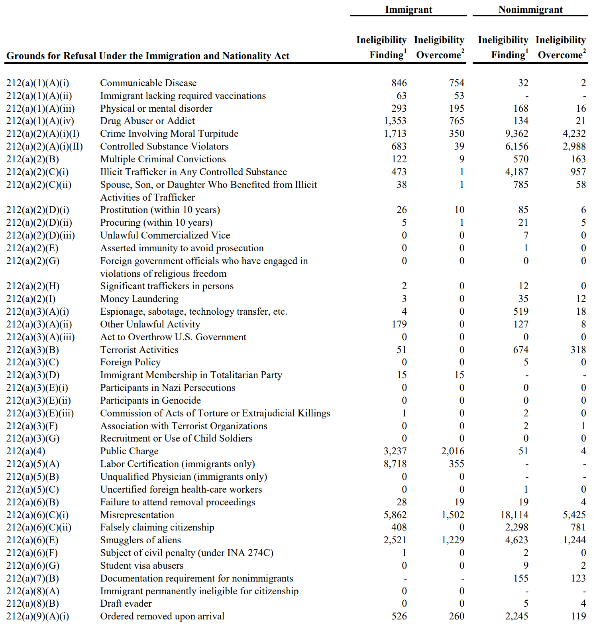
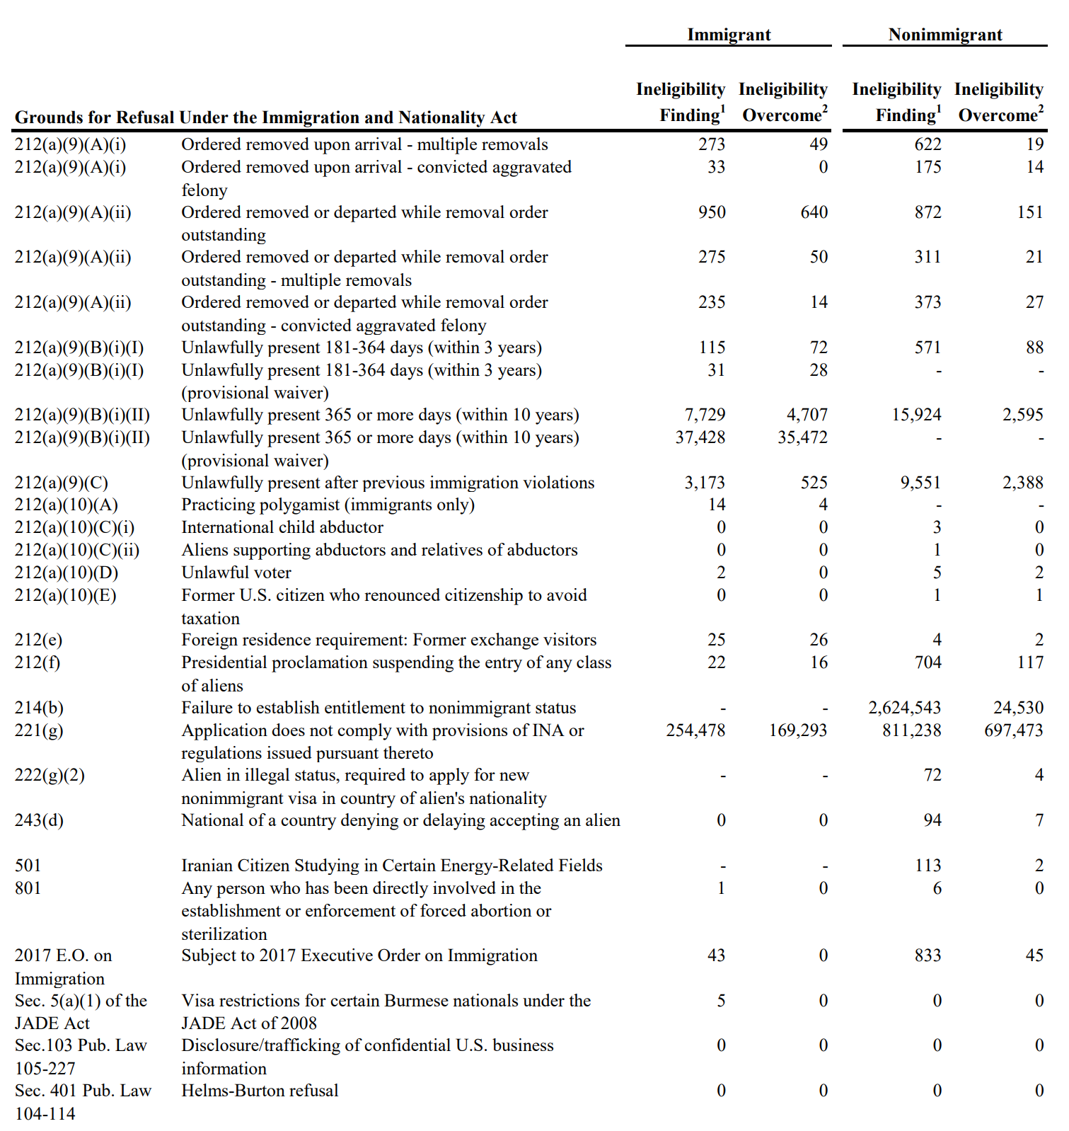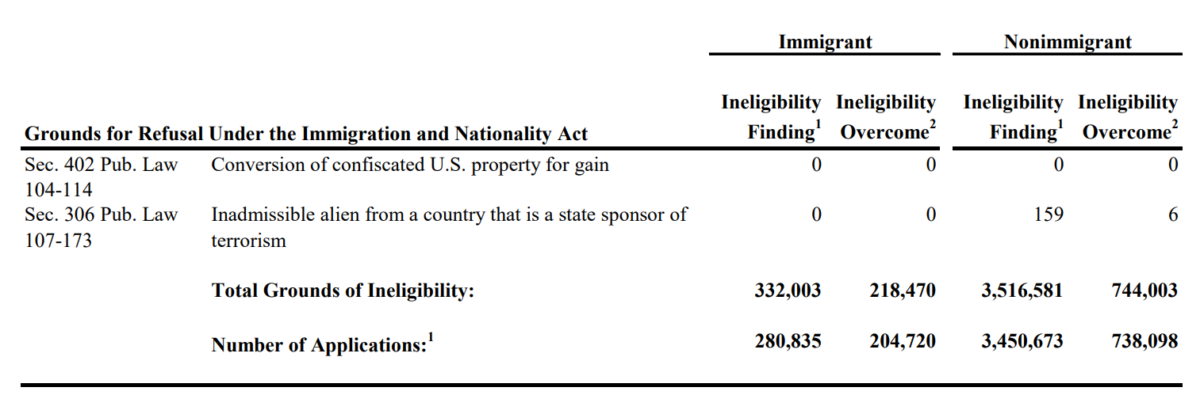

T- Restrictions—AFF

Restrictions = Qualitative and Quantitative Barriers

Restrictions on legal immigration are qualitative and quantitative barriers on admission in 5 categories
Tasoff 16 - Certified Specialist in Immigration Law (State Bar of California Board of Legal Specialization) since 1985 and has exclusively practiced immigration law for over 40 years. He was a past chair of the S. Calif. Chapter of the American Immigration Lawyers Association (AILA) and is a partner in the Law Firm of Tasoff and Tasoff (“Immigration Law After Trump” https://www.tasoff.com/Immigration-Information/Immigration-Law-After-Trump.pdf
Quantitative and Qualitative Restrictions on Legal Immigration
There are two barriers stopping the masses from legally immigrating to the U.S. First there are quantitative restrictions, quotas, which limit the number of people who can come to the U.S. in any one category of eligibility or from a specific country5 . Second, there are qualitative restrictions – people that Congress has determined should not be allowed to live here due to a myriad of reasons ranging from criminal convictions and health issues to membership in terrorist organizations6 . Although there are waivers for some grounds, most require a showing of extreme hardship to a close U.S. citizen or LPR relative.
The various categories of noncitizens that Congress has given a path to LPR status can be basically broken down into five groups: family based immigration, employment based immigration, refugees/asylees, investors and successful applicants to a “diversity” lottery selection process. See the accompanying Chart for more details regarding the family and employment based categories.

Restrictions govern quantity, type, and terms of admission
Posner 6 – Kirkland and Ellis Professor of Law, University of Chicago Law School
(Eric Posner, "The Second-Order Structure of Immigration Law.” https://chicagounbound.uchicago.edu/cgi/viewcontent.cgi?article=1571&context=law_and_economics)
A central goal of immigration policy for all states is, at a very high level of abstraction, to expand the polity by admitting desirable people.13 Nonetheless, states have different attitudes about which potential immigrants are desirable under various circumstances. These differences lead states’ first-order policy preferences to diverge along three main dimensions: with respect to the quantity of immigrants, the type of immigrants, and the terms of admission.14
Quantity. States can choose a range of numerical restrictions. At one extreme, a state permits no immigration; at the other extreme, a state permits unlimited immigration.15 Nearly all states choose intermediate points, but there is still a great deal of variation. Prior to the twentieth century, the United States had no formal numerical limits; beginning in 1921, the United States imposed an immigration ceiling of 350,000 on the Eastern Hemisphere.16 Over time, that ceiling ranged from 150,000 (in 1927) to 700,000 (in 1990) and since 1965 has covered the entire globe.17 Because of exceptions to the ceilings, actual immigration has been somewhat higher; for example, in 2004 legal immigration exceeded 946,000.18 By comparison, legal immigration in the same year was 202,300 in Germany, 175,200 in France, 88,300 in Japan, 235,800 in Canada, and 266,500 in the United Kingdom.19
Quantity restrictions can take various forms. As noted above, the U.S. federal government placed few formal restrictions on immigration prior to the 1870s.20 During this period, the government often took steps to increase the size of the immigrant flow.21 Even after the federal government began to place statutory limits on the types of immigrants who could enter, it did not place numerical restrictions on the overall size of the immigrant flow. The first statutory limits on the annual flow of immigrants were not adopted until shortly after World War I.22 These initially temporary limits were codified in the national origins quota system a few years later, but even these quota laws applied only to the Eastern Hemisphere.23 Only in the last forty years has the United States established relatively rigid global numerical restrictions on the annual number of immigrants the country will admit.24
Type. States also regulate the type of person who may immigrate. Some states use a point system that favors applicants with desired characteristics.25 These typically include the ability to speak the native language, work skills, educational achievement, and propensity to obey the law. For example, Canada awards points to applicants who are highly educated; who speak English and French proficiently; who have work experience; who are between twenty-one and forty-nine years old; who have arranged for employment in Canada; and (under the category of “adaptability”) who have an educated spouse or partner, have had prior work experience in Canada, or have a family relation in Canada.26 The United States places more weight on family relationship, though it too favors immigrants who have desired work skills.27 Before it imposed numerical restrictions, the United States did not have such elaborate and specific criteria for type, but it would be a mistake to think that the type of immigrant is a new concern. The Alien and Sedition Acts passed by the first Congress permitted the deportation of disloyal or subversive aliens,28 and many states in the post-founding era had laws that permitted the expulsion (from state territory) of public charges and criminals.29 Starting in 1875, Congress passed laws designed to exclude noncitizens on the basis of race (initially Chinese, then covering noncitizens from most of East and South Asia) and later on the basis of national origin (disfavoring, for example, southern Europeans).30 Today, the United States treats a criminal record as an important indication that a person is of an undesired type.31
Terms of admission. States also differ in the status that they confer on those permitted to immigrate. At one extreme, a state may confer full citizenship on an immigrant; at the other extreme, a state may permanently deny an immigrant the legal incidents of citizenship. For example, while the United States places substantial constraints on the numbers and types of immigrants it admits, today it places relatively few conditions on their terms of admission. Most noncitizens admitted to lawful permanent residence in the United States have a relatively easy path to citizenship.32 They must live in the country for five years before becoming eligible to naturalize, but this is nearly the only meaningful condition they must satisfy.33 Many other states have been less welcoming. In Germany, for example, a guest worker system under which resident workers (and their children) were ineligible for citizenship was the norm for much of the twentieth century.34 Moreover, the naturalization requirements have not always been so easy to satisfy in the United States. Until 1952, the United States restricted naturalization on the basis of race, which had the effect of permanently depriving some immigrants of access to full membership in the political community.35
We should be clear that we describe here only the immigrant admission system in the United States, not the system used to admit nonimmigrants. Nonimmigrants are those noncitizens admitted for a temporary period, such as tourists or employees who receive temporary authorization to work in the country.36 Immigrants, by contrast, are admitted to permanent residence in the country—residence that is not contingent on retaining employment, learning English, and so forth—and are on a path to eventual citizenship. (For that reason admitted immigrants are typically referred to as “lawful permanent residents”). We focus on the structure of the immigrant system, because our interest here is in the system that the state uses to select those in the immigrant pool whom it considers desirable to add to the country’s population and eventually to the citizenry.37 As we explain below, however, a state might choose to use a temporary immigration system—such as a guest worker program—as a screening mechanism for potential permanent immigrants.38
This highlights one last important point about first-order preferences—a point that foreshadows the following discussion on second-order design. Though restrictions concerning immigrant numbers, types, and terms of admission often reflect a state’s first-order preferences, they need not always do so. Because such restrictions are closely interrelated, a restriction along one dimension can be used as an instrument to advance a different first-order preference. Restrictions on terms of admission are, as we note above, one example of this. Numerical restrictions offer another example: they can reflect a first-order preference, but can also be used as a second-order mechanism to control the types of immigrants (and vice versa). The national origins quota system that Congress enacted in 1924 was designed to do just this: the quota law’s formula was intended to constrict the flow of immigrants from southern and eastern Europe, whom Congress saw as racially inferior to their western and northern European counterparts.39

Restriction ≠ Prohibition

Restrict doesn’t mean prohibit
Coffey 82 - US Circuit Judge, dissenting (VICTOR D. QUILICI, ROBERT STENGL, et al., GEORGE L. REICHERT, and ROBERT E. METLER, Plaintiffs-Appellants, v. VILLAGE OF MORTON GROVE, et al., Defendants-Appellees Nos. 82-1045, 82-1076, 82-1132 UNITED STATES COURT OF APPEALS FOR THE SEVENTH CIRCUIT 695 F.2d 261; 1982 U.S. App. LEXIS 23560, lexis)
Pursuant to section 83, a municipality can enact an ordinance reasonably restricting or confining the use and possession of firearms. A municipality can also require registration of firearm ownership. What the legislature has authorized is limited regulation of firearm possession by local units of government, but not prohibition. Section 83 does not allow a municipality such as Morton Grove to categorically prohibit handgun possession. [**35] To limit or restrict involves a circumscription which falls far short of an absolute prohibition.
"The words 'prohibit' and 'restrict' are not synonymous. They are not alike in their meaning in their ordinary use . . . . 'To restrict is to restrain within bounds; to limit; to confine and does not mean to destroy or prohibit.'"

Restrictions Definitions

Counter interp—Restrictions can be implicit
Business Dictionary No Date, “Restrictions”, http://www.businessdictionary.com/definition/restrictions.html
Limitations which cannot be exceeded or rules which cannot be broken. These can be either explicit or implicit. For example, a company may have restrictions on employees from taking personal calls unless it is an emergency

Restrictions mean limitations by regulation
William C. Burton 2007, Washington lobbyist who has devoted his practice to insurance and banking legislative and regulatory matters, “Restriction”, https://legal-dictionary.thefreedictionary.com/restriction
any limitation on activity, by statute, regulation or contract provision. In multi-unit real estate developments, condominium and cooperative housing projects, managed by homeowners' associations or similar organizations are usually required by state law to impose restrictions on use. Thus, the restrictions are part of the "covenants, conditions and restrictions," intended to enhance the use of common facilities and property, recorded and incorporated into the title of each owner.

Restrictions are boundaries that limit movement
​Cambridge No Date, “restriction Definition in the Cambridge English Dictionary”, https://dictionary.cambridge.org/us/dictionary/english/restriction,
something that limits someone's actions or movement, or limits the amount, size, etc., of something:

Restrictions on Immigration is defined as a policy designed to protect immigrants from foreign competition
Howard F. Chang 09, the Earle Hepburn Professor of Law at the University of Pennsylvania Law School, “IMMIGRATION RESTRICTION AS REDISTRIBUTIVE TAXATION: WORKING WOMEN AND THE COSTS OF PROTECTIONISM IN THE LABOR MARKET”, http://www.lexisnexis.com/hottopics/lnacademic/?verb=sf&sfi=AC02NBGovPolSrch, Spring
Despite these considerations, many observers favor immigration restriction as a policy designed to protect native workers from foreign competition. n3 In the United States, these protectionists claim that the entry of immigrant workers has increased income inequality among natives substantially. n4 Protectionists concerned about distributive justice among citizens often infer that we should restrict immigration insofar as the entry of alien workers causes such an increase in income inequality among natives. n5 In this article, I will focus on this concern regarding income inequality in particular, setting aside the other reasons that restrictionists may have for opposing more liberal immigration policies.

Context Key

Restriction must be defined in context
Haneman 59 – Justice for the Superior Court of New Jersey, Appellate Division
(J.A.D., 12/4. “RUSSELL S. BERTRAND, ET AL., PLAINTIFFS-RESPONDENTS, v. DONALD T. JONES, ET AL., DEFENDANTS-APPELLANTS,” 58 N.J. Super. 273; 156 A.2d 161; 1959 N.J. Super. LEXIS 569)
HN4 In ascertaining the meaning of the word "restrictions" as here employed, it must be considered in context with the entire clause in which it appears. It is to be noted that the exception concerns restrictions "which have been complied with." Plainly, this connotes a representation of compliance by the vendor with any restrictions upon the permitted uses of the subject property. The conclusion that "restrictions" refer solely to a limitation of the manner in which the vendor may [***14] use his own lands is strengthened by the further provision found in said clause that the conveyance is "subject to the effect, [**167] if any, of municipal zoning laws." Municipal zoning laws affect the use of property.
HN5 A familiar maxim to aid in the construction of contracts is noscitur a sociis. Simply stated, this means that a word is known from its associates. Words of general and specific import take color from each other when associated together, and thus the word of general significance is modified by its associates of restricted sense. 3 Corbin on Contracts, § 552, p. 110; cf. Ford Motor Co. v. New Jersey Department of Labor and Industry, 5 N.J. 494 (1950). The [*284] word "restrictions," therefore, should be construed as being used in the same limited fashion as "zoning."

Permanent Residence—NEG

T-Permanent Residence—1NC

Immigration means to settle into a foreign country permanently
Oxford No Date, “immigration | Definition of immigration in English by Oxford Dictionaries”, https://en.oxforddictionaries.com/definition/immigration
action of coming to live permanently in a foreign country. ‘a barrier to control illegal immigration from Mexico’

Violation—the aff has to change immigration policy based on permanent residence

Vote neg—anyone can be settling in the US for a temporary amount of time—that unlocks the topic to illegal immigration, refugees, tourist; etc. which ruins fairness and education

Permanent Residence Interpretations—2NC

Immigration means to travel into a country for permanent residence
Merriam-Webster No Date, “Immigration” https://www.merriam-webster.com/dictionary/immigration
an act or instance of immigrating; specifically : travel into a country for the purpose of permanent residence there

Legal immigration is permanent residence—temporary migrants are distinct from legal immigration
Deardorff and Blumerman 2 (Kevin Deardorff, Chief, Economy Wide Statistics Division, U.S. Census Bureau. Lisa M. Blumerman-Associate Director for Decennial Census Programs. “Evaluating Components of International Migration: Estimates of the Foreign-Born Population by Migrant Status in 2000”, Working Paper #58)
Legal Immigrants (L) The Immigration and Nationality Act defines legal immigration as the process by which a non-citizen of the United States is granted legal permanent residence. A non-citizen with legal permanent residence status may remain in the country, be employed, travel freely, and seek naturalization to become a U.S. citizen. Legal immigrants, as categorized by the Census Bureau, include new arrivals to the United States, people adjusting their migrant status to legal permanent resident (including Special Agricultural Workers (SAWs) and pre-1982 entrants (LAWs)), asylees, and refugees (Perry et al., 2001). We estimated the number of legal immigrants using Immigration and Naturalization Service (INS) data. In 2000, the estimate of survived legal immigrants ([L - (M + E)]) was 21,612,023. Foreign-Born Emigrants (E) Foreign-born legal emigrants were residents of the United States who departed from the United States to reside abroad. Unauthorized migrants, migrants from Puerto Rico, temporary migrants, and natives (U.S. citizens at birth) are excluded from this population universe. For purposes of the DAPE project, we estimated the number of emigrants from a residual methodology using data on the foreign-born population by period of entry from two consecutive censuses (Mulder et al., 2001). We used the resulting number of emigrants to calculate rates of emigration. Although these emigration rates reflect the behavior of the entire foreign-born population, they were used as a reasonable proxy for the legal immigrant population. By applying these emigration rates to the legal immigrant population annually from 1990 to 2000, we estimated the number of emigrants from the legal population between 1990 and 2000. Mortality (M) Survival rates for the legal immigrant population were calculated from life tables of the total population by sex and single year of age (Mulder et al., 2001). Although these survival rates were calculated for the total population, they were used as a reasonable proxy for the legal immigrant population. By applying these survival rates to the legal immigrant population, we estimated the number of deaths that occurred to this population between 1990 and 2000. Temporary Migrants (T) The Immigration and Nationality Act defines temporary migrants (also referred to as nonimmigrants) as aliens admitted to the United States for a specified purpose and temporary period, but not for permanent residence. Temporary migrants, as categorized by the Census Bureau and defined for the remainder of this paper, include those who would be considered residents of the United States for purposes of the decennial census, including foreign students and temporary workers, but excluding tourists and business workers (see Cassidy and Pearson, 2001).

H1-B Violation—1NC

H1-B is a temporary work visa
Miriam Jordan 2018, national immigration correspondent, “What Are H-1B Visas, and Do They Hurt American Workers?”, New York Times, April 6, https://www.nytimes.com/2018/04/06/us/what-are-h1b-visas.html
What is the H-1B visa?
It is a temporary visa that employers use to hire foreigners in “specialty occupations” for which there are not enough skilled American workers to fill available jobs. The workers must have at least a bachelor’s degree. It enables those employed to legally work in the United States for three years, with the possibility of extensions.

Violation—H1-B visas are temporary--not permanent

Vote neg-- anyone can be settling in the US for a temporary amount of time—that unlocks the topic to illegal immigration, refugees, tourist; etc.—ruins fairness and education

H2-B Violation—1NC

H2-B is a temporary work visa
H1-Base No Date, http://www.h1base.com/content/h2bvisa
Who Qualifies for an H2B visa
The H2B visa is available to employers of foreign non-professionals Not working in the agricultural field. This visa is only available for work that is temporary in nature. For H2B purposes, that means:
- Recurring seasonal need;
- Intermittent need;
- Peak-load need; and
- One time occurrence.
H2B Visa duration:
The duration of the H2B is limited to the employer's need for the temporary workers. The maximum authorized period is one year. However, the employer may extend the duration up to three years in some situations.

Violation—the aff is a temporary visa not a permanent one

Vote neg-- anyone can be settling in the US for a temporary amount of time—that unlocks the topic to illegal immigration, refugees, tourist; etc. which ruins fairness and education

Permanent Residence—AFF

Counter-Interpretation—2AC

Counter Interpretation—Immigration can be semi-permanent residence
FAIR No Date, “The DOs and DON'Ts of Key Immigration Terms” http://www.easybib.com/v2/mla8/website-citation/eval
Immigration: The process of entering one country from another to take up permanent or semi-permanent residence. See also emigration.

T-Refugees

T-Refugees—NEG

T-Refugees—1NC

Refugees fall under migration not immigration
Adrian Vore 15, the Local section editor, South/East County section editor and the Readers' Representative at The San Diego Union-Tribune, “Opinion Readers' Representative 'Immigrant' vs. 'migrant'; what's the difference?”, http://www.sandiegouniontribune.com/opinion/readers-rep/sdut-immigrant-migranr-undocumented-europe-syria-2015sep25-story.html, September 25
Tatiana Sanchez, the U-T’s immigration reporter, said immigrants are willingly settling in a country. She said migrants are more associated with refugees, or they are workers moving from job to job with seasons. L.A. Times reporter Alexandra Zavis, who’s covering the European crisis, explained why the word migrants is used, not immigrants, in reports on the subject. “Migrant is a broad term that includes refugees and those moving for economic reasons. We have been using the term in our reporting about the crisis in Europe because many of these people are still on the move, and some may wish to return home one day. Immigrant refers to those who have moved to a foreign country with the intention of settling there.” Zavis wrote about the descriptions of those flooding into Europe in an article Sept. 11 and the importance the meanings play in the crisis.

Violation— the aff reduces restrictions on refugees not immigrants

Vote neg—migration is a broad term that includes refugees—anyone can be considered a migrant—destroys predictable limits

T-Refugee Interpretations—2NC

Legal immigration is distinct from refugees
Yakushko et al 5 (Oksana Yakushko, Counseling Psychology Department, University of Missouri–Columbia; Krista M. Chronister, Counseling Psychology Department, University of Oregon. Oksana Yakushko is now at the Counseling Psychology Department, University of Nebraska at Lincoln, “Immigrant Women and Counseling: The Invisible Others”, http://www.access-dv.org/pdfs/Yakushko%20&%20Chronister.pdf , 2005)
Immigration constitutes a wide array of relocation circumstances, which have a strong bearing on women’s experiences in their host environments. The three broad categories of relocation that are officially recognized in the U.S. are (a) legal immigration, (b) refugee relocation, and (c) undocumented or “illegal” immigration. Legal immigration refers to relocation of noncitizens who are granted legal permanent residence by the U.S. federal government. Legal permanent residence provides the right to remain in the country indefinitely, to be gainfully employed, and to seek benefits of U.S. citizenship through naturalization (Mulder et al., 2001). This status does not give the right to vote or receive benefits, such as many federal subsidies reserved for U.S. citizens. A different type of immigration status is granted to individuals who are considered refugees. Refugees are defined by the 1967 United Nations Protocol on Refugees as those people outside their country of nationality who are unable or unwilling to return to that country because of persecution or well-founded fear of persecution (Mulder et al., 2001). The third category of U.S. immigrants represents individuals who seek to relocate to the U.S. in search of employment and better living conditions. Often referred to as the “illegal” or “undocumented” population, the unauthorized migrant population consists primarily of two groups: (a) those who enter the U.S. without inspection and (b) those who enter the U.S. with legal temporary visas but stay beyond the time allotment of their visas (Mulder et al., 2001). The U.S. Census Bureau (Mulder et al., 2001) estimates that approximately 5 to 8 million individuals remain in the U.S. without legal documents, with Mexicans constituting 95% of undocumented immigrants who are detained in the U.S. (Portes & Rumbaut, 1996).

A refugee is someone who is forced to migrate distinct from an immigrant
Martinez et al 14, Michael--Honor Medal for Distinguished Service in Journalism: Staff award for CNN Digital, “What's the difference between immigrant and refugee?”, https://www.cnn.com/2014/07/15/us/immigrant-refugee-definition/index.html, July 16
The Central Americans crossing the U.S. border in massive waves have been described as immigrants or refugees. The distinction is significant and could determine whether the migrants are subject to deportation to their home country or eligible to remain in the United States under asylum. What is an immigrant? An immigrant is someone who chooses to resettle to another country. The United States has a legal process for that immigrant to seek legal residency and eventually citizenship. Many immigrants, however, don't have such legal status and are thus undocumented. As such, they are subject to "removal" or deportation from the United States. There are 11 million undocumented immigrants in the United States -- a problem that has led Democrats and Republicans alike to declare the U.S. immigration system as "broken." Congress has been deadlocked for years on how to reform immigration laws. "Migrants, especially economic migrants, choose to move in order to improve the future prospects of themselves and their families," the U.N. High Commissioner for Refugees says. "Refugees have to move if they are to save their lives or preserve their freedom." What is a refugee? A refugee is someone who has been forced to flee his or her home country. As such, refugees can apply for asylum in the United States, a process that could take years. Getting refugee status isn't easy. The applicants have to prove that if they return to their home country, they'll be injured because of their race, religion, nationality, membership in a particular social group or their political opinion. "Refugees are generally people outside of their country who are unable or unwilling to return home because they fear serious harm," the U.S. Citizenship and Immigration Services says. The Central Americans overwhelming the U.S.-Mexican border are Hondurans, Guatemalans and Salvadorans. Many are fleeing drug- and gang-fueled violence back home. Is the violence -- any kind -- grounds for a refugee claim? Not necessarily. The violence has to be targeted to a person specifically, and that's where things get complicated. Every case is different, and because of a law signed by President George W. Bush in 2008, children fall into a special class. The William Wilberforce Trafficking Victims Protection Action Act, named after a 19th century British abolitionist, is designed to crack down on the global child slave trade. The U.S. law ensured that children who came to the country got a full immigration hearing instead of being turned away or sent back. The hearing would determine whether the children had a valid claim for asylum. The law is now cited as one cause behind a projected 90,000 children from Central America and Mexico who will cross the U.S. border alone or with other children this year, a huge increase over the 39,000 that the Border Patrol detained last year. Asylum is a protection available to people who are already in the United States or are seeking admission at the U.S. border.

T-Refugees—AFF

Counter Interpretation—2AC

Counter-interp: refugees are included in legal immigration
CFR 18 ,Council on Foreign Relations “The U.S. Immigration Debate”, https://www.cfr.org/backgrounder/us-immigration-debate-0 , Last updated March 13, 2018, Accessed 5/22/18
Legal immigration. The United States granted nearly 1.2 million individuals [PDF] legal permanent residency in 2016, more than two-thirds of whom were admitted based on family reunification. Other categories included: employment-based preferences (12 percent), refugees (10 percent), diversity (4 percent), and asylees (3 percent). In late 2017 there were more than four million applicants on the State Department’s waiting list for immigrant visas [PDF].

Refugees fall under legal immigration
Federal Code 17 (Code of Federal Regulations: 1985-1999, https://books.google.com/books?id=YQMWlyvoJhIC&pg=PA225&lpg=PA225&dq=%22the+term+legal+immigration%22&source=bl&ots=enndBaRt8x&sig=4N2vLnx_U-QNiC4CMUS2asQYpnA&hl=en&sa=X&ved=0ahUKEwjvu47gjvzaAhXidd8KHRZgDmQQ6AEIMjAC#v=onepage&q=%22the%20term%20legal%20immigration%22&f=false , Pg 225-6 , Digitized Jan 31, 2017)
(11) Any alien admitted as a visitor under the visa waiver provisions Of 5 212.1(e) Of this chapter.
(c) Definitions—(1) Legal Immigration Status. For purposes Of section Of the Act, the term "legal immigration status" is limited to individuals who are:
(i) In lawful permanent resident status;
(ii) Admitted in nonimmigrant status as defined in section 101(a)(15) of the Act, or whose nonimmigrant status has been extended in accordance with part 214 of this chapter;
(iii) In refugee status under section 207 Of the Act, such status not having been revoked;
(iv) In asylee status under section 208 of the Act, such status not having been revoked; or
(v) In parole status which has not expired.

T-Legal Immigration

T-Legal Immigration—NEG

T-Legal Immigration—1NC

Interpretation: legal immigration refers to relocated noncitizens with permanent legal status not refugees or undocumented individuals
Yakushko et al 5, Oksana Yakushko, Counseling Psychology Department, University of Missouri–Columbia; Krista M. Chronister, Counseling Psychology Department, University of Oregon. Oksana Yakushko is now at the Counseling Psychology Department, University of Nebraska at Lincoln. Correspondence concerning this article should be addressed to Oksana Yakushko, 235 Teachers College Hall, University of Nebraska at Lincoln, Lincoln, NE 68588-0345 (e-mail: oyakushko2@unl.edu). “Immigrant Women and Counseling: The Invisible Others”, http://www.access-dv.org/pdfs/Yakushko%20&%20Chronister.pdf , 2005
Immigration constitutes a wide array of relocation circumstances, which have a strong bearing on women’s experiences in their host environments. The three broad categories of relocation that are officially recognized in the U.S. are (a) legal immigration, (b) refugee relocation, and (c) undocumented or “illegal” immigration. Legal immigration refers to relocation of noncitizens who are granted legal permanent residence by the U.S. federal government. Legal permanent residence provides the right to remain in the country indefinitely, to be gainfully employed, and to seek benefits of U.S. citizenship through naturalization (Mulder et al., 2001). This status does not give the right to vote or receive benefits, such as many federal subsidies reserved for U.S. citizens. A different type of immigration status is granted to individuals who are considered refugees. Refugees are defined by the 1967 United Nations Protocol on Refugees as those people outside their country of nationality who are unable or unwilling to return to that country because of persecution or well-founded fear of persecution (Mulder et al., 2001). The third category of U.S. immigrants represents individuals who seek to relocate to the U.S. in search of employment and better living conditions. Often referred to as the “illegal” or “undocumented” population, the unauthorized migrant population consists primarily of two groups: (a) those who enter the U.S. without inspection and (b) those who enter the U.S. with legal temporary visas but stay beyond the time allotment of their visas (Mulder et al., 2001). The U.S. Census Bureau (Mulder et al., 2001) estimates that approximately 5 to 8 million individuals remain in the U.S. without legal documents, with Mexicans constituting 95% of undocumented immigrants who are detained in the U.S. (Portes & Rumbaut, 1996).

Violation— the aff reduces restrictions on undocumented individuals/refugees not LEGAL immigration

Vote neg—the AFF opens the topic to both legal and illegal immigration avenues which ruins a predictable limit with precise research

Legal Immigration Interpretations—2NC

Interpretation--Legal immigration means that the immigrant would have to have LPR status and be legally recorded
CIS No Date, “Topic Page: Legal Immigration”, https://cis.org/Legal-Immigration
"A Green Card holder (permanent resident) is someone who has been granted authorization to live and work in the United States on a permanent basis. . .You can become a permanent resident several different ways. Most individuals are sponsored by a family member or employer in the United States. Other individuals may become permanent residents through refugee or asylee status or other humanitarian programs. In some cases, you may be eligible to file for yourself…Any person not a citizen of the United States who is residing the in the U.S. under legally recognized and lawfully recorded permanent residence as an immigrant. Also known as "Permanent Resident Alien," "Resident Alien Permit Holder," and "Green Card Holder."

To immigrate legally must be authorized
Oxford No Date, “Definition of legal immigration in US English”, https://en.oxforddictionaries.com/definition/us/legal_immigration
Immigration which is officially authorized; opposed to illegal immigration.

T-Legal Immigration—AFF

We Meet/CI—2AC

We meet—Immigration is the process by which immigrants become legally naturalized citizens- the aff provides immigrants with a legal process towards legalization
LII 17, “Immigration”, https://www.law.cornell.edu/wex/immigration” January 30th
Immigration Law: An Overview Federal immigration law determines whether a person is an alien, the rights, duties, and obligations associated with being an alien in the United States, and how aliens gain residence or citizenship within the United States. It also provides the means by which certain aliens can become legally naturalized citizens with full rights of citizenship. Immigration law serves as a gatekeeper for the nation's border, determining who may enter, how long they may stay, and when they must leave.

T-Reduce

T-Reduce—NEG

T-Reduce is Make Smaller—1NC

Reduce means to make smaller in size
Merriam Webster No Date, “reduce”, https://www.merriam-webster.com/dictionary/reduce
a : to draw together or cause to converge : consolidate ·reduce all the questions to one b (1) : to diminish in size, amount, extent, or number ·reduce taxes ·reduce the likelihood of war (2) : to decrease the volume and concentrate the flavor of by boiling ·add the wine and reduce the sauce for two minutes c : to narrow down : restrict ·the Indians were reduced to small reservations d : to make shorter : abridge

Violation—the plan increases restrictions through [x]

Vote neg—increasing and decreasing restrictions makes the topic bi-directional and explodes the lit base and ruins research practices and topic ground is predicated on a reduction in restrictions

T-No Elimination—1NC

Reduce excludes eliminate.
Words and Phrases 2002 (vol 36B, p. 80)
Mass. 1905. Rev.Laws, c.203, § 9, provides that, if two or more cases are tried together in the superior court, the presiding judge may “reduce” the witness fees and other costs, but “not less than the ordinary witness fees, and other costs recoverable in one of the cases” which are so tried together shall be allowed. Held that, in reducing the costs, the amount in all the cases together is to be considered and reduced, providing that there must be left in the aggregate an amount not less than the largest sum recoverable in any of the cases. The word “reduce,” in its ordinary signification, does not mean to cancel, destroy, or bring to naught, but to diminish, lower, or bring to an inferior state.—Green v. Sklar, 74 N.E. 595,

Violation—the plan eliminates [x]

Vote neg—

Fairness—the aff destroys the research burden—we only have links predicated off of the assumption that the aff reduces restrictions not eliminating them

AFF

T-Reduce means to fix—2AC

Counter Interp—Reduce means to fix—the aff corrects the legal status of [X]
Merriam Webster No Date, “reduce”, https://www.merriam-webster.com/dictionary/reduce
: to correct (a fracture) by bringing displaced or broken parts back into their normal positions

T-Plural

T-Plural—NEG

T-Plural—1NC

Interpretation—the plan must reduce restrictions
TalkEnglish No Date, http://www.talkenglish.com/grammar/singular-plural-nouns.aspx
For the plural form of most nouns, add s.
bottle – bottles
cup – cups
pencil – pencils
desk – desks
sticker – stickers
window – windows

Violation—the plan only reduces one restriction on legal immigration

Vote neg—

Advocacy skills- means the aff only have to defend one tiny restriction instead of multiple

Neg ground—means we can’t have specific counterplans and we can’t pic out of the aff because they defend only one restriction

Specification

Restrictions Spec—NEG

Restrictions Spec—1NC

The devil is in the details—the AFF must specify policy details-- Vote neg for depth education and precise ground
Ollstein 18 (Alice Ollstein is a reporter at Talking Points Memo, covering national politics. She graduated from Oberlin College in 2010 and has been reporting in DC ever since, covering the Supreme Court, Congress and national elections for TV, radio, print, and online outlets. Her work has aired on Free Speech Radio News, All Things Considered, Channel News Asia, and Telesur, and her writing has been published by The Atlantic, La Opinión, and The Hill Rag. She was elected in 2016 as an at-large board member of the DC Chapter of the Society of Professional Journalists. Alice grew up in Santa Monica, California and began working for local newspapers in her early teens. “Trump’s Scattershot Immigration Remarks Leave Congress Reeling”, https://talkingpointsmemo.com/dc/trumps-scattershot-immigration-remarks-leave-congress-reeling , January 10, 2018)
Devil in the details When it came to the actual policy details, the divisions were just as stark. Republicans touted the meeting for “narrowing down” the immigration deal to four provisions: ending so-called “chain migration,” canceling the visa lottery program, beefing up border security and offering some form of relief for the young immigrants who lost their protection from deportation when Trump canceled the DACA program last year. But the list is an expansion from the original proposal to pair DACA with border security measures alone, and there is not yet any agreement on any of the four provisions currently under discussion. “The tone was good, but the devil is in the details,” Schumer observed. Sen. Jeff Flake (R-AZ), who attended the meeting, also said he would reserve judgement until he knew what the White House means by “comprehensive immigration reform.” “Everybody says they want it. Defining it is a bigger problem,” he said. But rather than making those clear policy asks, Trump ended the meeting by throwing up his hands and instructing Congress to work it out on their own, saying he would sign anything put in front of him. “You folks are going to have to come up with a solution, and if you do I’m going to sign it,” he said.

Restrictions Spec—AFF

Implicit—2AC

Restrictions can be implicit
Business Dictionary No Date, “Restrictions”, http://www.businessdictionary.com/definition/restrictions.html
Limitations which cannot be exceeded or rules which cannot be broken. These can be either explicit or implicit. For example, a company may have restrictions on employees from taking personal calls unless it is an emergency

Counter Interp—Restrictions don’t have to be legally explicit
Mapbox No Date, “Mapping implicit turn-restrictions”, https://www.mapbox.com/mapping/mapping-for-navigation/implicit-restrictions/
Implicit turn restrictions are turn restrictions that are implied by local laws, safe driving norms, or the real-world physical layout of roads, but are not accompanied by explicit signs (posts or road paint). When a junction is missing an implicit turn restriction, a routing engine may direct the driver to make an illegal or dangerous maneuver.

T-Substantially

Substantial(ly)

T-Substantial—1NC

Interpretation--

A substantial reduction is at least 50-75%
Glosbe No Date, “substantial reduction in English”, https://glosbe.com/en/en/substantial%20reduction
For reasons explained at length in the decision, none of the companies meets the conditions for obtaining immunity from fines, a "very substantial" reduction of the fine (i.e. at least 75%) or even a "substantial" reduction (i.e. between 50% and 75%).

Substantially means at least 50%
Selya 5, (Justice, United States Court of Appeals for the First Circuit, 408 F.3d 41; 2005 U.S. App. LEXIS 9539)
For instance, the BAA permits the use of foreign goods if it is in the "public interest," 41 U.S.C. § 10d, and Law 109 does not contain such an exception. There are also disparities between the BAA and Law 109 as the former has been interpreted in federal regulations. One such disparity is that the preference for domestic construction materials in procurement by federal agencies is 6%, see 48 C.F.R. § 25.204(b), whereas the Preference Board currently sets the preference for purposes of Law 109 at 15%. Furthermore, the BAA requires contracts for construction of public buildings to favor items manufactured in the United States that are "substantially all" composed from American raw materials. 41 U.S.C. § 10b. The applicable federal regulation defines "substantially all" as meaning at least 50%. See 48 C.F.R. § 25.101(a)(2). In contradistinction, Law 109 seems to require that cement be manufactured 100% from indigenous (Puerto Rican) raw materials, save for those indigenous materials that are unavailable in commercial quantities. See 3 P.R. Laws Ann. § 927(d).

Violation—the aff is not a substantial reduction of 50%

Vote neg—

Limits: the aff allows a proliferation of affs that can substantially reduce restrictions of any amount

Neg ground outweighs—links based on the plan text are virtually impossible—offense is predicated off of the assumption the aff reduces a large amount of restrictions

Substantial = Double

Substantial mandates doubling
SIMON 89 taught Business Admin at Maryland, senior fellow at Cato.
teaches Business Administration at the University of Maryland and is a Senior Fellow at the Cato Institute
(Julian Simon, “The Economic Consequences of Immigration into the United States” http://www.juliansimon.com/writings/Immigration/CHAP16.txt)

The total number of immigrants to be admitted legally is the key economic element of immigration policy. If no applicants will be admitted legally, the only remaining immigration decisions concern illegal immigrants. If all applicants will be admitted, there are no further decisions to be made. The alternatives that I think realistic are: a) substantially more immigrants than now, b) substantially less immigrants than now, and c) about the same number as now. By "substantially" I mean a change up to a doubling (and perhaps subsequent doublings) or halving of the immigration rate. Furthermore, it would seem likely that, given the nature of politics and social decision-making in the United States, changes in the amount of immigration would be made in several steps - a sequential process of "muddling through" as we learn by trial and error. Recommending only "substantially more" or "substantially less" would seem to be consistent with this prevailing political process. A recommendation of either zero immigrants or an open door would have no chance of being adopted by American society now or in the forseeable future, and therefore it would hardly be useful to make either recommendation even if it were warranted on strictly economic grounds.

Substantially = materially/essentially

Substantially means materially
Words and Phrases, 2 (Words and Phrases Permanent Edition, “Substantially,” Volume 40B, p. 324-330 October 2002, Thomson West)
Minn. 1977. Under section of Environment Rights Act providing remedy against a defendant whose conduct materially adversely affects environment, the word “materially” carries the effect and meaning as the word “substantially,”

Substantial = W/O material Qualifications

Substantially is without material qualification
Black’s Law Dictionary 1991
[p. 1024]
Substantially - means essentially; without material qualification.

Substantial defs

Substantial is to a large extent
Oxford Dictionary No Date, “substantially”, https://en.oxforddictionaries.com/definition/substantially
To a great or significant extent. ‘profits grew substantially’ as submodifier ‘substantially higher pension costs’

Substantial is a significant amount
Lectlaw No Date, “SUBSTANTIAL”, https://www.lectlaw.com/def2/s086.htm
Significant in size or amount as distinguished from some relatively insubstantial, insignificant or trivial amount

2AC—Substantially = Vague

Substantial(ly) cannot be measured—its too vague
Ken Adams 18, Author at Adam’s drafting, “Substantial” and “Substantially”, http://www.adamsdrafting.com/substantial-and-substantially/, January 25
Substantial and substantially exhibit the same problem as aggressively, which I ranted about in this October 2010 AdamsDrafting blog post. How big does something have to be before it is substantial or can be said to do something substantially? More than 50% of its maximum potential magnitude? More than 70%? 85.42%? I have no idea. So the subjectivity inherent in vagueness is compounded by imprecision. Maybe substantial and substantially refer to a magnitude that’s close enough to the maximum that a reasonable person in the position of whoever has the benefit would be satisfied. That may be the case, but I’m not aware that that meaning is sufficiently accepted that you can take it for granted.

General Neg cards

AT: Reasonability—2NC

Reasonability is bad—It’s vague and there’s no Brightline to what is reasonable or not
Ken Adams 18, Author at Adam’s drafting, “Substantial” and “Substantially”, http://www.adamsdrafting.com/substantial-and-substantially/, January 25
It’s good to be precise. But when the future is sufficiently uncertain that you can’t be precise, vagueness comes in handy. But there’s vague and there’s vague. Consider reasonable. Because reasonableness isn’t determined by objective criteria, determining whether a given act is reasonable requires (1) a potentially messy inquiry into the surrounding circumstances and (2) measuring the findings against one’s notions of reasonableness. So determining reasonableness is an exercise in line-drawing, and there’s no guarantee that you and I are going to come to the same conclusion regarding whether a given act was reasonable.

